Capsulefy: User manual

When not logged in, an user is only able to list capsules that have been released, search a specific capsule using a keyword contained in the title, release date or description.

By clicking on “Search capsules” a list with all the capsules available will appear, as well as a search bar

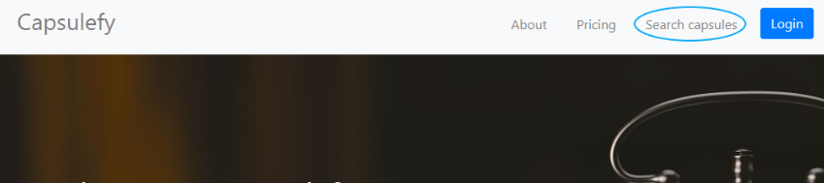

By clicking on “Display capsule” the contents of the capsule will be fully displayed.

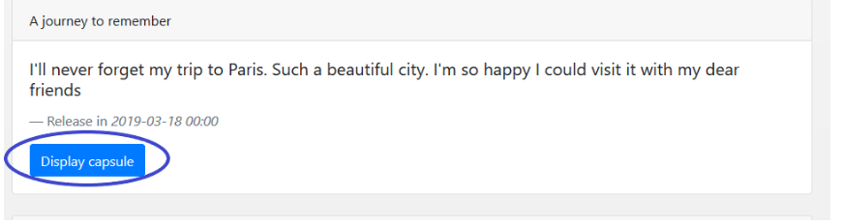

When logged in, each user can create free capsules, with the restriction of only being able to store inside them up to 20mb in total per user.

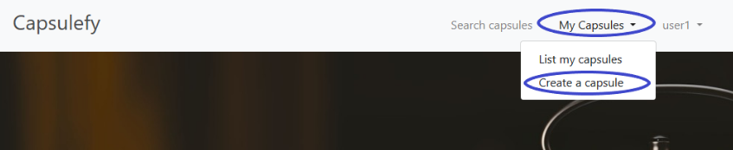

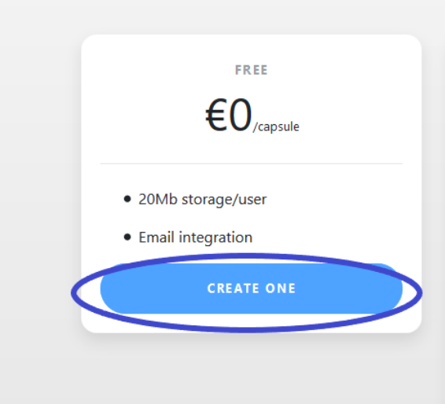

In order to create the capsule, it is necessary to introduce at least a title, a description and a publication date following the pattern yyy-mm-dd, being yyyy the year, mm the month and dd the day. In the email fields, multiple emails can be entered, separated by “;”, and an email will be sent to them when the capsule is released. Finally, files can be uploaded, as long as they don’t exceed the free user limit. Capsules published by the user logged in can be listed by clicking “my capsules”. These capsules can be edited as long as they have not been released and they can be deleted anytime.